International training programme at Earth University, Costa Rica

Title:- EARTH University’s Education Model

Objectives of training:-
- To learn new concepts in teaching and learning process
- To get an ideas about infrastructure and landscape facilities of earth university campus
- To look for the opportunities in student exchange
- To collect useful literature from the university
Name of the staff participated
- Prof. Gaikwad Sandeep, Assistant professor of Agricultural extension, College of Agriculture, Baramati
- Prof. Patil Pranavsingh, Assistant professor of Agronomy,
College of Agriculture, Baramati
- Prof. Mundhe Suryakant, Principal, High school sharadabai pawar vidyaniketan
- Prof. Ghodke Amol, Headmaster, Primary school sharadabai pawar vidyaniketan
- Prof. Puri Arun, Professor of Eduation, Specialization Guidance & Counseling

Glimpses of training
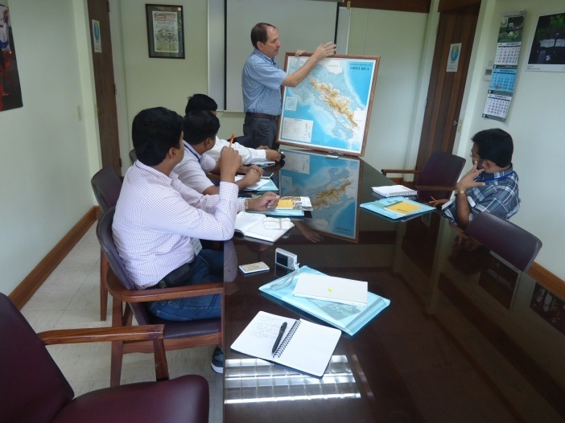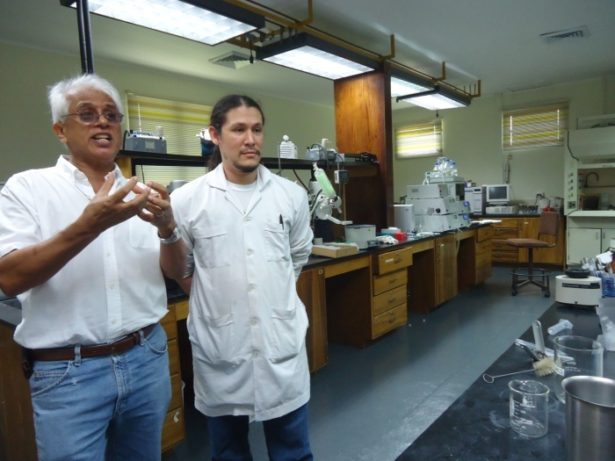
Meeting with Provost, Daniel Sherrard Soil Lab visit With Prof. B.K. Singh
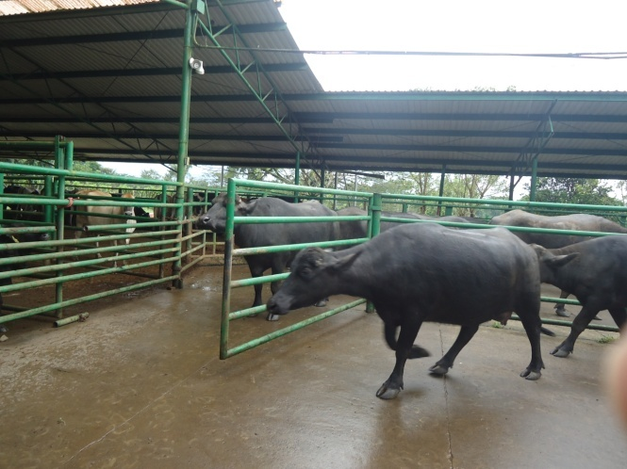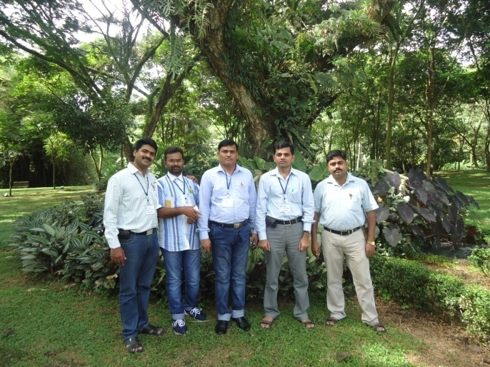
Visit to dairy unit Group members in training
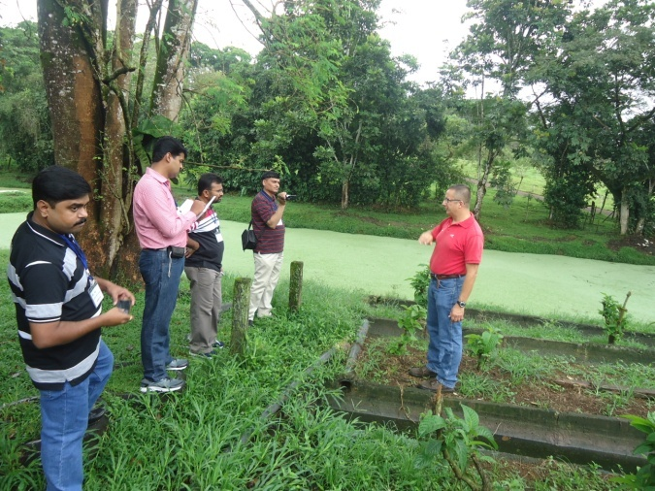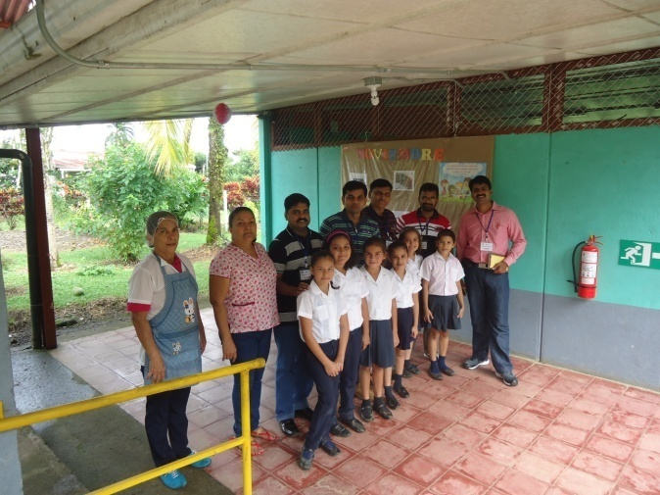
Visit to water purifier unit Visit to primary school in Costa Rica

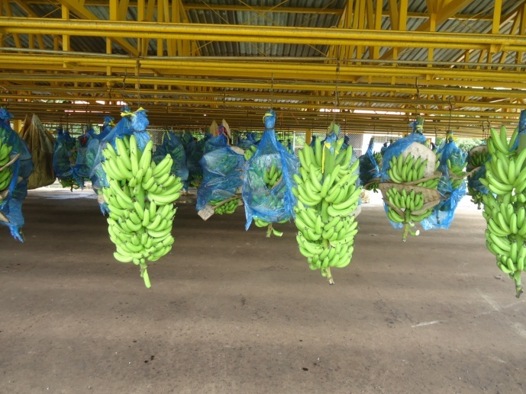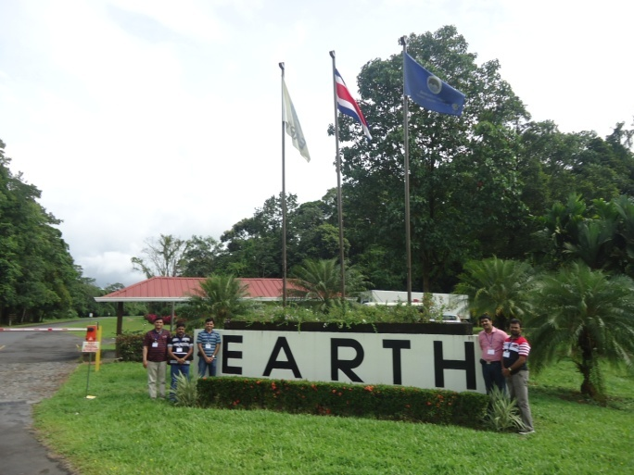
Visit to banana packaging unit At Earth University’s main gate
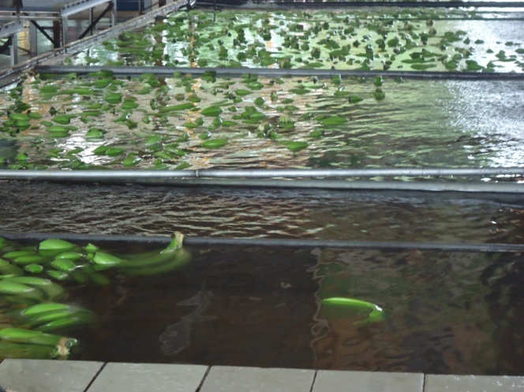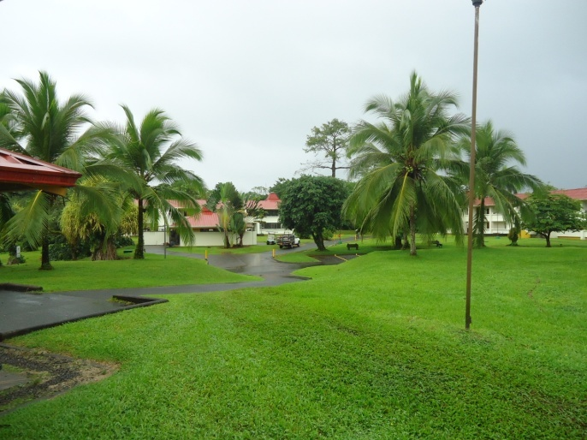
Banana being washed before packing Landscape designs at Earth University
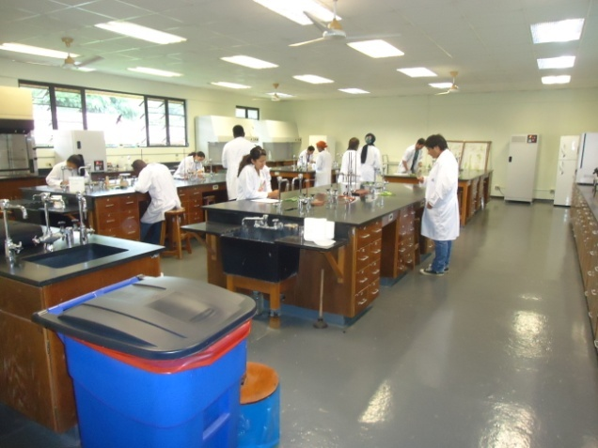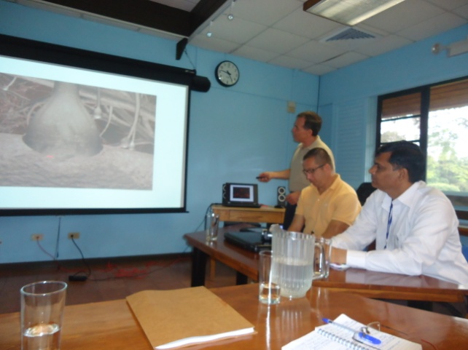
Visit to plant protection lab Lectures delivered by Prof. Manuel Cerrato

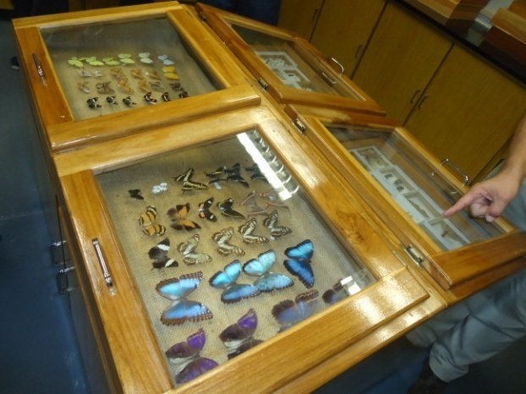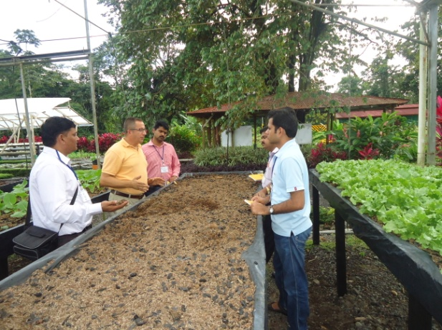
Visit to plant protection lab Visit to students project unit
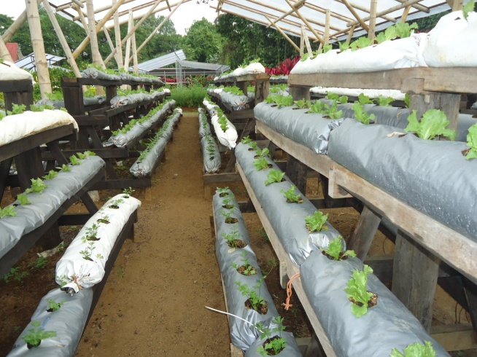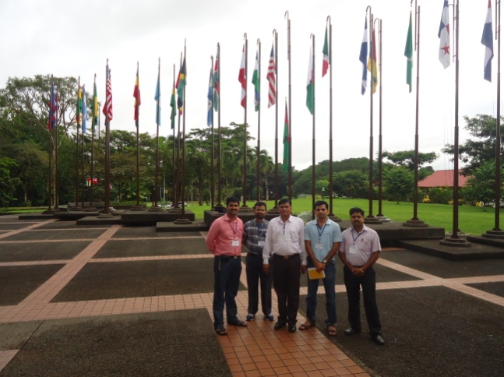

Visit to students project unit Flags hosting on degree allotment day

